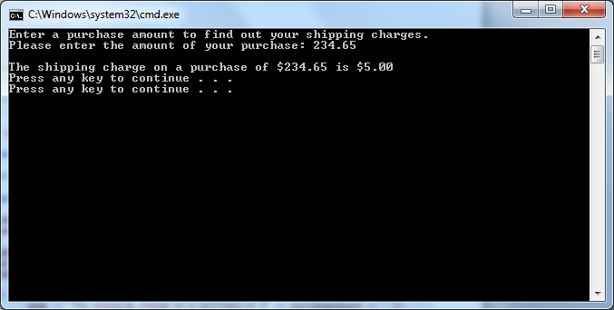

// ---------------------------------------------------------------

// Developer: Kevin Nguyen

// Date Written: May 15, 2015

// Purpose: Calculate Shipping Charge

// ---------------------------------------------------------------

#include<iostream>

usingnamespace std;

void main()

{

double purchaseAmount;

cout <<"Enter a purchase amount to find out your shipping charges.";

cout << endl;

cout <<"Please enter the amount of your purchase: ";

cin >> purchaseAmount;

cout << endl;

if (purchaseAmount > 5000){

cout <<"The shipping charge on a purchase of $"<< purchaseAmount <<" is $20.00";}

elseif (purchaseAmount > 1000 && purchaseAmount <= 5000){

cout <<"The shipping charge on a purchase of $"<< purchaseAmount <<" is $15.00";}

elseif (purchaseAmount > 500 && purchaseAmount <= 1000){

cout <<"The shipping charge on a purchase of $"<< purchaseAmount <<" is $10.00";}

elseif (purchaseAmount > 250 && purchaseAmount <= 500){

cout <<"The shipping charge on a purchase of $"<< purchaseAmount <<" is $8.00";}

elseif (purchaseAmount > 0 && purchaseAmount <= 250){

cout <<"The shipping charge on a purchase of $"<< purchaseAmount <<" is $5.00";}

else {cout <<"Error: incorrect input.";}

cout << endl;

system("pause");

}